
DEPARTMENT OF COMPUTER APPLICATION

AI FitTrack API

TEAM ID:
TEAM LEADER:
Deepika M -7ADA9771BFAF125811C4C63BF12FD3DA
TEAM MEMBERS:
k.safana parveen-533DF0A1358722A8CE34BD5B3C4A4BFC
Kamesh A-61B8CD0D79456D5B3F54B658A496CC31
Evelin J-C46CEE82BCE4F8F83B84B5C94F100EE9

FitTrack is a fitness tracking system developed to help users monitor and manage their daily fitness activities. In today’s busy lifestyle, people often find it difficult to keep track of their physical activities, exercise routines, steps, and calories. FitTrack provides a simple platform where users can record and monitor their fitness information.

The main purpose of FitTrack is to encourage users to maintain regular physical activity and develop healthy habits. The system allows users to enter their daily workout details and view their progress over time.

Problem Statement
Many people do not properly track their daily physical activities. They may forget their workout schedules, steps, or calorie information. Maintaining fitness records manually can also be difficult and time-consuming.
FitTrack solves this problem by providing a digital system for recording and managing fitness information in an organized way.

Objectives
The main objectives of the FitTrack project are:
- To provide an easy-to-use fitness tracking system.
- To record daily physical activities.
- To maintain workout information.
- To track steps and calories.
- To monitor fitness progress.
- To help users develop regular exercise habits.
- To store user information securely.

Scope of the Project
FitTrack can be used by students, working people, and anyone interested in monitoring their fitness activities. The system can be further developed with features such as wearable-device integration, notifications, personalized workout plans, and fitness reports.

SYSTEM FEATURES AND TECHNOLOGIES

Main Features
User Registration and Login:
Users can create an account and log in to the system using their credentials.

User Profile:
Users can maintain basic information such as name, age, height, weight, and fitness goals.

Workout Tracking:
Users can record their daily workouts, including exercise type and duration.

Step Tracking:
The system can maintain the number of steps completed by the user.

Calorie Tracking:
Users can record or monitor calories burned during physical activities.

Progress Monitoring:
The system displays the user's fitness progress based on the recorded information.

Functional Requirements
The system should allow users to:
Register and log in.
Update their profile.
Add workout details.
Record daily steps.
Record calorie information.
View previous fitness records.
Monitor their progress.

Non-Functional Requirements
The system should be easy to use.
The application should respond quickly.
User information should be protected.
The system should be reliable.
The interface should be simple and user-friendly.

Technologies Used
Frontend: HTML, CSS, JavaScript
Backend: Node.js / PHP
Database: MongoDB / MySQL
The frontend is used to create the user interface. The backend handles application logic and user requests. The database stores user profiles, workout records, and fitness information.

SYSTEM WORKFLOW AND CONCLUSION

System Workflow
The basic workflow of FitTrack is:
User Registration → Login → User Profile → Add Fitness Activity → Store Data → View Progress
First, the user registers and logs into the system. After logging in, the user can enter or update profile information. The user can then add daily fitness activities such as workouts, steps, and calories. The information is stored in the database and can be viewed later to monitor progress.

Advantages
Easy to maintain fitness records.
Saves time compared with manual tracking.
Helps users monitor daily activities.
Provides organized fitness information.
Encourages regular physical activity.
Allows users to view their progress.

Future Enhancements
In the future, FitTrack can be improved by adding:
Smartwatch and fitness-band integration.
Automatic step counting.
Personalized workout recommendations.
Diet and nutrition tracking.
Daily fitness reminders.
Graphs and detailed progress reports.
Mobile application support.

Conclusion
FitTrack is a useful fitness tracking system that helps users manage and monitor their daily physical activities. It provides features for recording workouts, steps, calories, and fitness progress in an organized manner.
The project demonstrates how technology can be used to support fitness management and encourage users to maintain regular physical activity. With additional features and improvements, FitTrack can become a more advanced and user-friendly fitness management application.

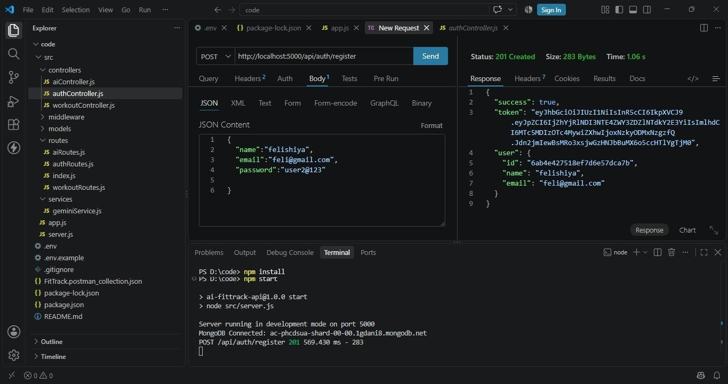

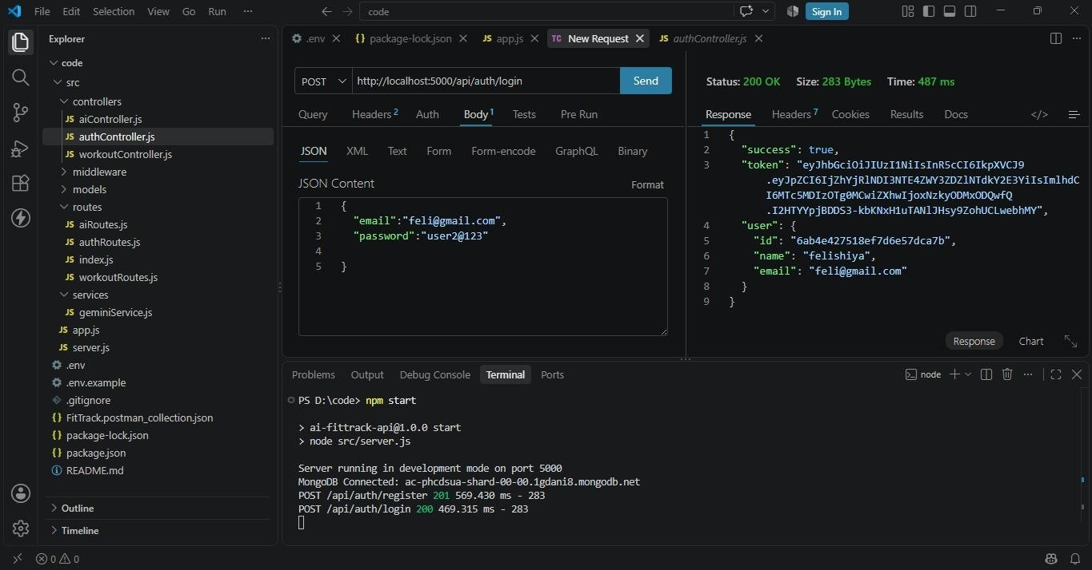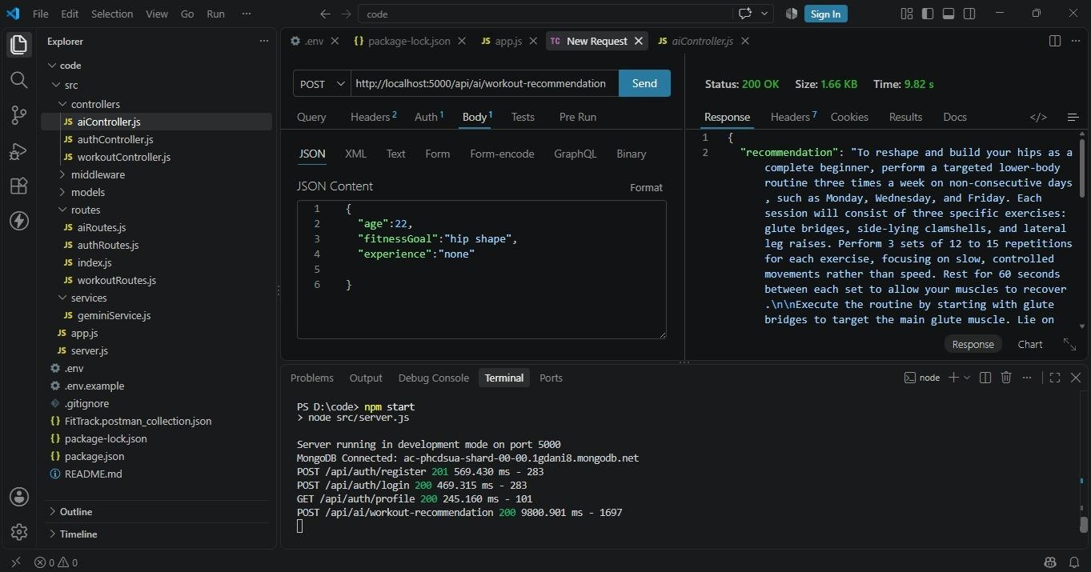

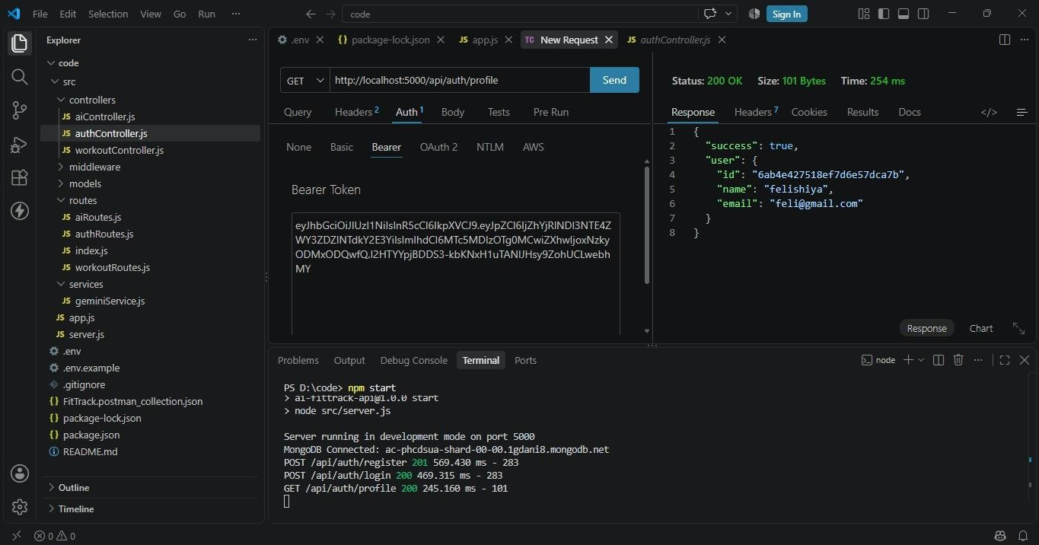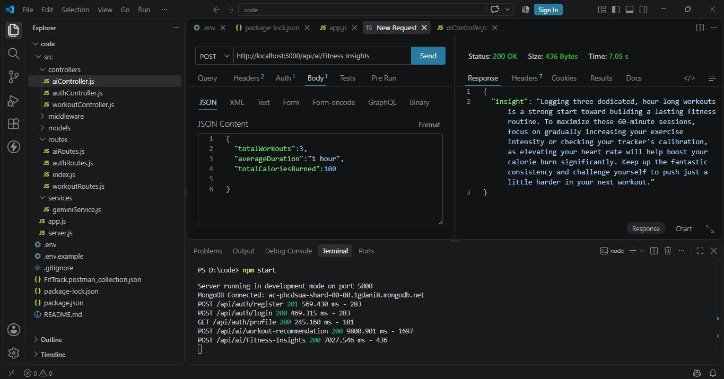

Demo Link: https://drive.google.com/file/d/1Oi3Eouru8LgdHol5_P0Q6y7MTzSoatQs/view?usp=drive_link

GitHub link :
https://github.com/deepikam03/ai-fittrack-api

